**(ProsperLoanDataset) ## by (Daisy Wambui Njung'e)**

**prosperLoanData**

This dataset is contains data about people offered Loans. The dataset has 81 columns. The columns of interest that i've analyzed are Estimatedreturn,EstimatedLoss,Employmentstatus,Loanstatus among others.

**Summary of Findings**

The Employmentstatus affects various variables like Lenderyield,Estimatedloss and return. Variables such as Lenderyield and Borrowerrate have a positive correlation.

**Key Insights for Presentation**

**Which employmentStatus have a high count of borrowing loans?**

The employed,both fulltime and selfemployed have a higher borowwing count while the retired have a lower borrower count.

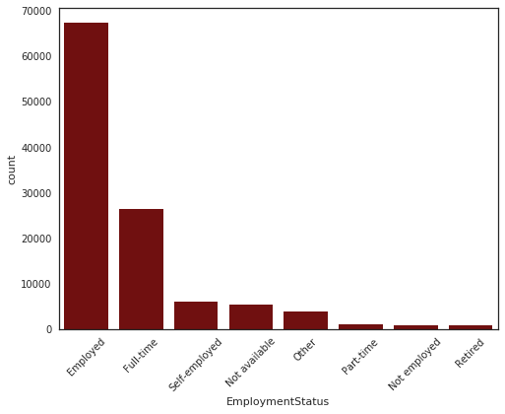

**What is the relationship between Estimatedloss and Borrowerrate?**

The higher the Borrower rate the higher the Estimatedloss.

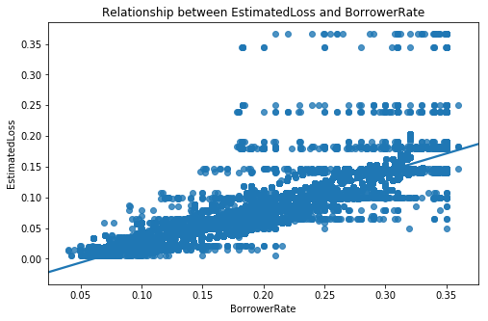

**Are LoanBorrowers currently in groups?**

Most loanborrowers are currently not in any groups.

